**10-26 notes**

Project 1 and GitHub

Goals:

By the end of this lesson, you will:

* Make progress toward completing your project, finding and analyzing a dataset of your choice.
* Be able to pull a branch from GitHub.
* Be able to merge branches with Git.
* Be able to open, review, and merge PRs with GitHub.

Branches allow for patches and features to be developed separately from main branch.

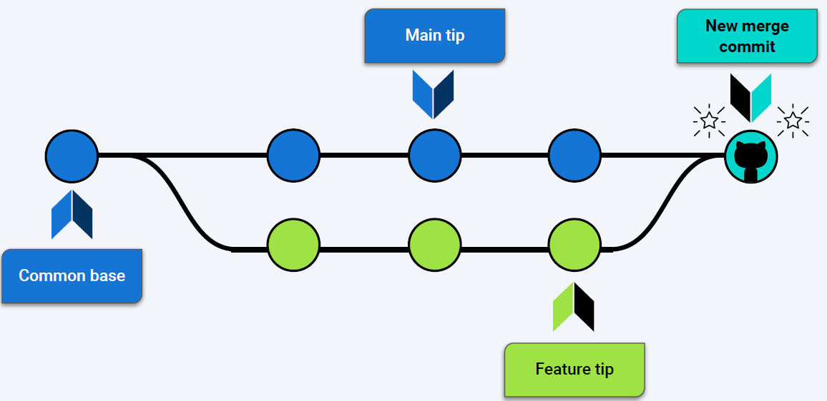

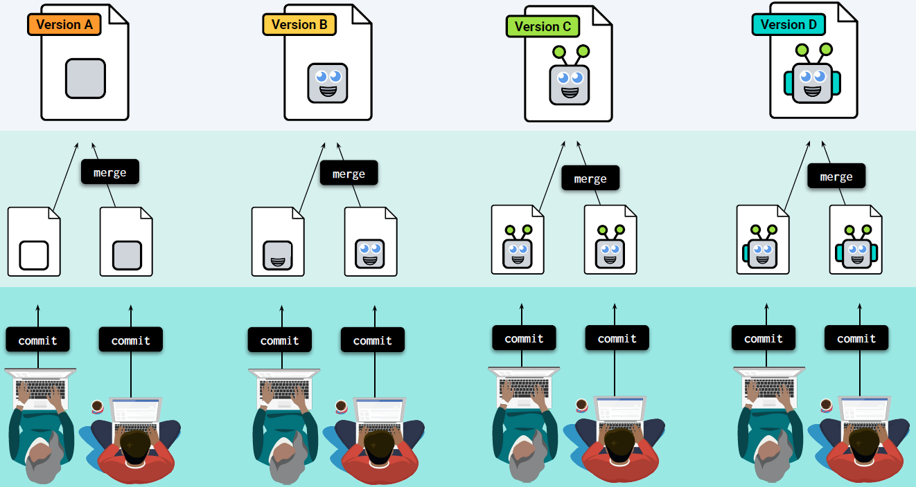

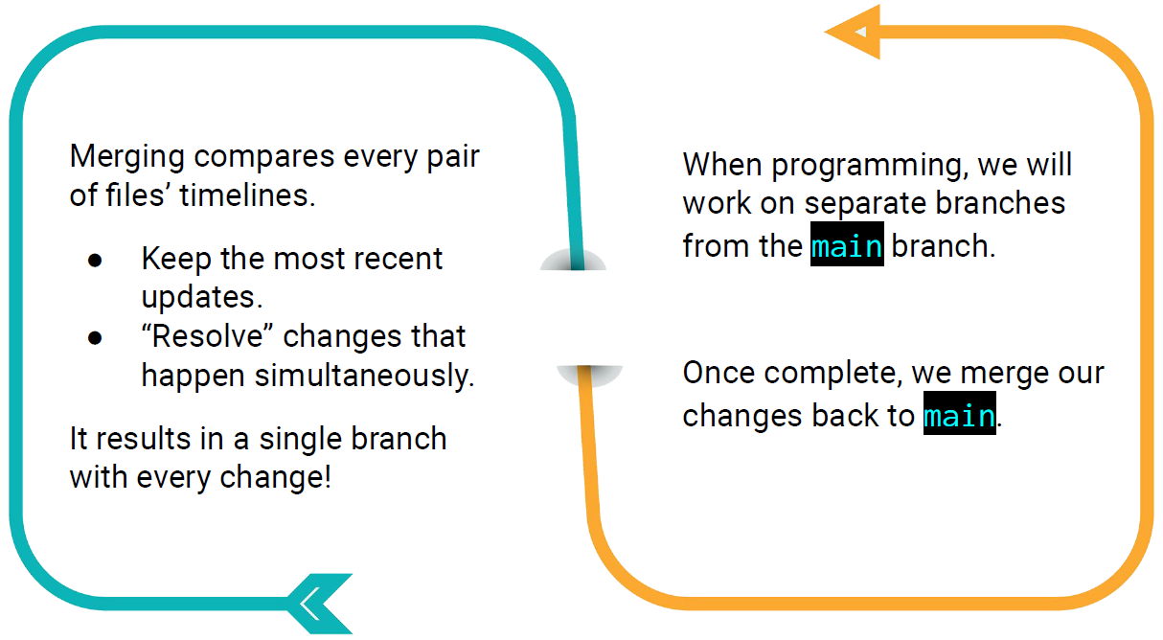

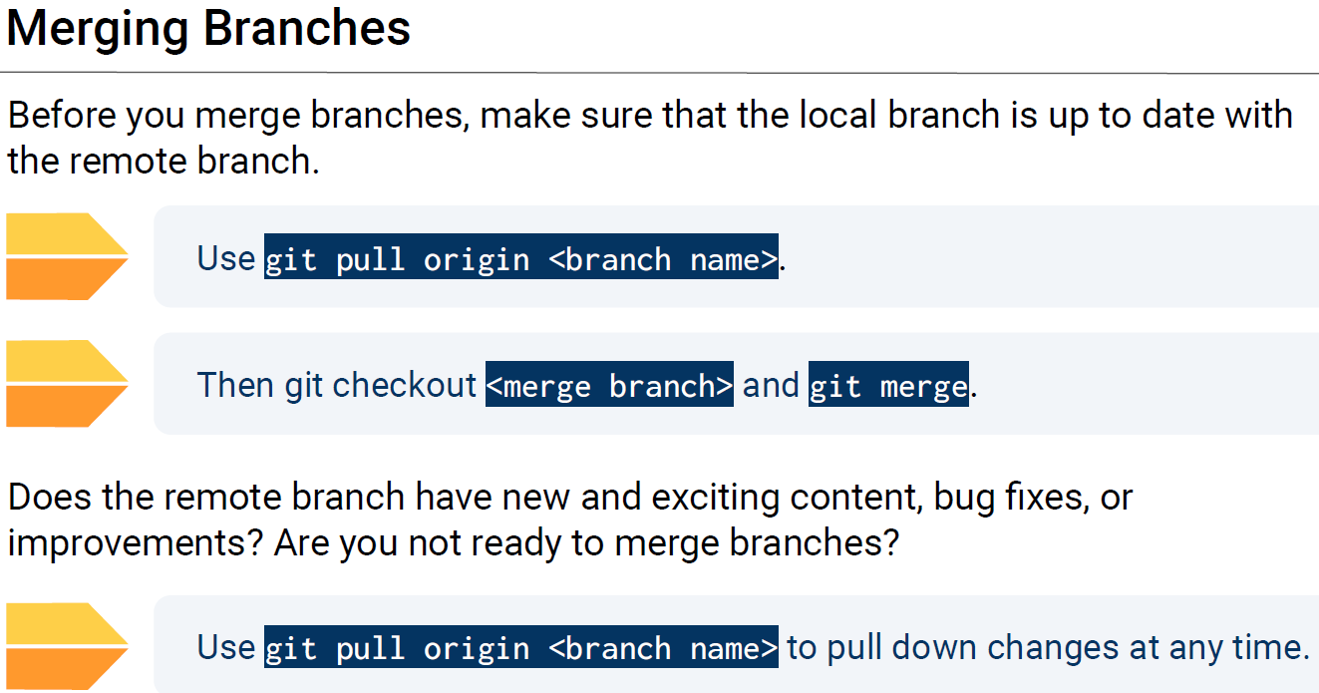

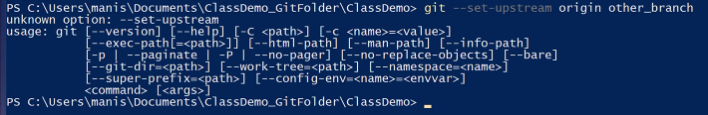

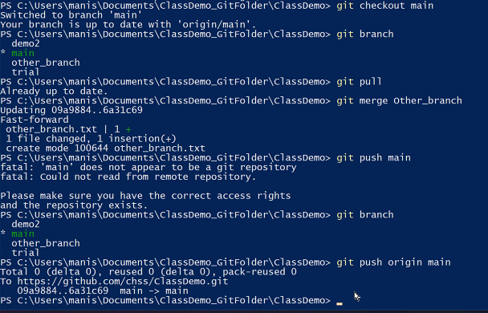

Manish’s request:

Use command prompt or powershell to pull orgin main, make a new branch, add a file, push branch

